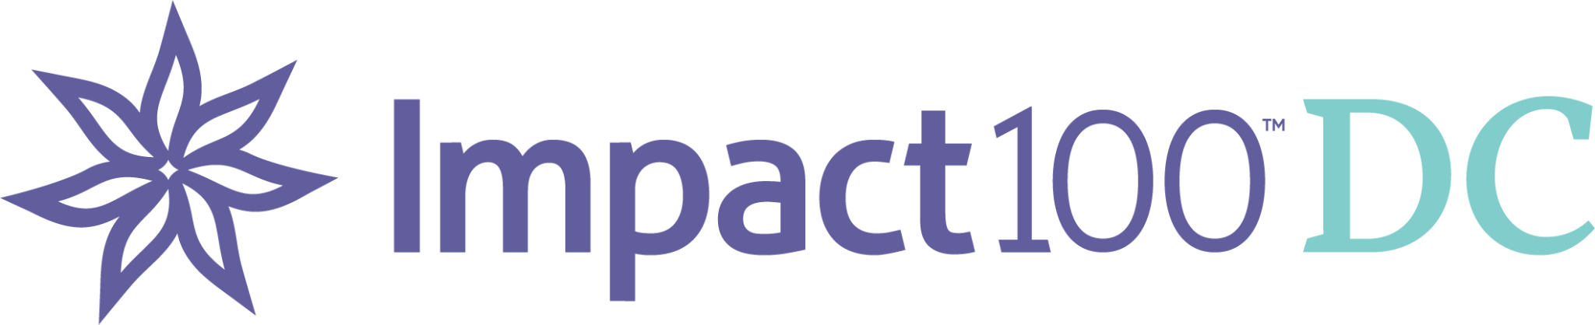

Dear XXXXX,

I am a member of a dynamic women’s philanthropic organization called [Impact100 DC](http://www.impact100dc.org). Our purpose is to award high-impact grants to community nonprofit organizations addressing local needs. In June, we completed our third grant cycle, awarding one $100,000 high-impact grant to a game-changing organization called [Open City Advocates](https://www.opencityadvocates.org/) and smaller grants of $20,666 to three wonderful nonprofits also working to address unmet needs. To date, we have awarded over $400,000 in grants. I am writing to ask you to join me for our fourth year. Our goal for 2024 is to award two $100,000 grants and three $10,000 grants, an increase from our current membership of 164 to 245. That is doable, with your help!

The concept of Impact100 is simple: 100+ members come together, pool annual membership contributions of $1,000, and, each year, award at least one transformational grant of $100,000 to a local nonprofit organization. We accept proposals from nonprofits working in five areas: health and wellness, family, education, arts and culture, and environment. We are grateful to be part of a national network of over 60 chapters. At the same time we are a fully autonomous 501C3 nonprofit organization with an exclusive focus on the unmet needs within our unique community - particularly those whose roots lie in systemic racism and inequity.

Members lead and participate in every aspect of the grant review process. We work hard to recruit individuals from all corners and demographics in the DC area. The collective wisdom, knowledge, experience, and perspective of a diverse Impact100 DC community are crucial to our success.

Every member has an equal voice in Impact100 DC. One woman, one $1,000 contribution, one vote. 100% of each yearly $1,000 contribution goes to creating the annual grant(s). We rely on Member Plus contributions of $100 and the support of community friends and corporate sponsors to defray critical operating expenses.

Women tailor their experience in Impact DC to suit their interests and available time. It can be enough to join and vote at the annual meeting. That said, volunteer needs are abundant, providing opportunities for members to contribute their expertise and experience as well as gain new skills.

I hope you will join the Impact100 DC community. I would be happy to answer any questions you may have. Please visit our website at [www.impact100dc.org](http://www.impact100dc.org) for more information and to join.

Best,

XXXXX